PLEASE TICK
(If you have multiple adults in your home wishing to comment please use the boxes below)

NAME:  SUPPORT 20 mph Speed limit  AGAINST 20 mph Speed limit | NAME:  SUPPORT 20 mph Speed limit  AGAINST 20 mph Speed limit
NAME:  SUPPORT 20 mph Speed limit  AGAINST 20 mph Speed limit | NAME:  SUPPORT 20 mph Speed limit  AGAINST 20 mph Speed limit

NOW RETURN TO THE PARISH CLERK BY 31st OCTOBER 2025

ADISHAM PARISH COUNCIL INVITES YOU TO HAVE YOUR SAY

What are your views on a 20mph limit
for The Street, Adisham?

Why a 20mph limit?

For many years a 20mph speed limit has been suggested and requested by some residents with concerns over the speed of the traffic. The School, the Village Hall and the recreation ground are accessed via The Street. Having a 20mph speed limit would certainly help with pedestrian safety in this area. Along The Street in places there are no footpaths making pedestrian safety a cause for concern. The limit will be indicated by 20mph signposts at the start of the limit; the tarmac will also have demarcation to indicate the speed either side of the School. With more electric vehicles, making little noise, using the roads in the future, it is important we prepare for this by reducing the speed of the vehicles.

However, it will only happen if support is demonstrated by the community, so please share your views.

The cost to the parish for this project is estimated to be approximately £5,000. This would cover implementation of the scheme such as, signage, road lining and traffic management, Importantly, Kent Highways have agreed to cover the Traffic Regulation Order and Design costs. In addition, to this offer, Kent Highways are confident that they can assist with some of the implementation costs, noted above.

Please only complete one form per household, including your address.

Please detach this page return to: Jean Swan. Adisham Parish Clerk, Plum Tree Cottage, The Street CT3 3JR;
or email: clerk@adisham-pc.gov.uk; or go to the website to complete the form: www.adisham-pc.gov.uk

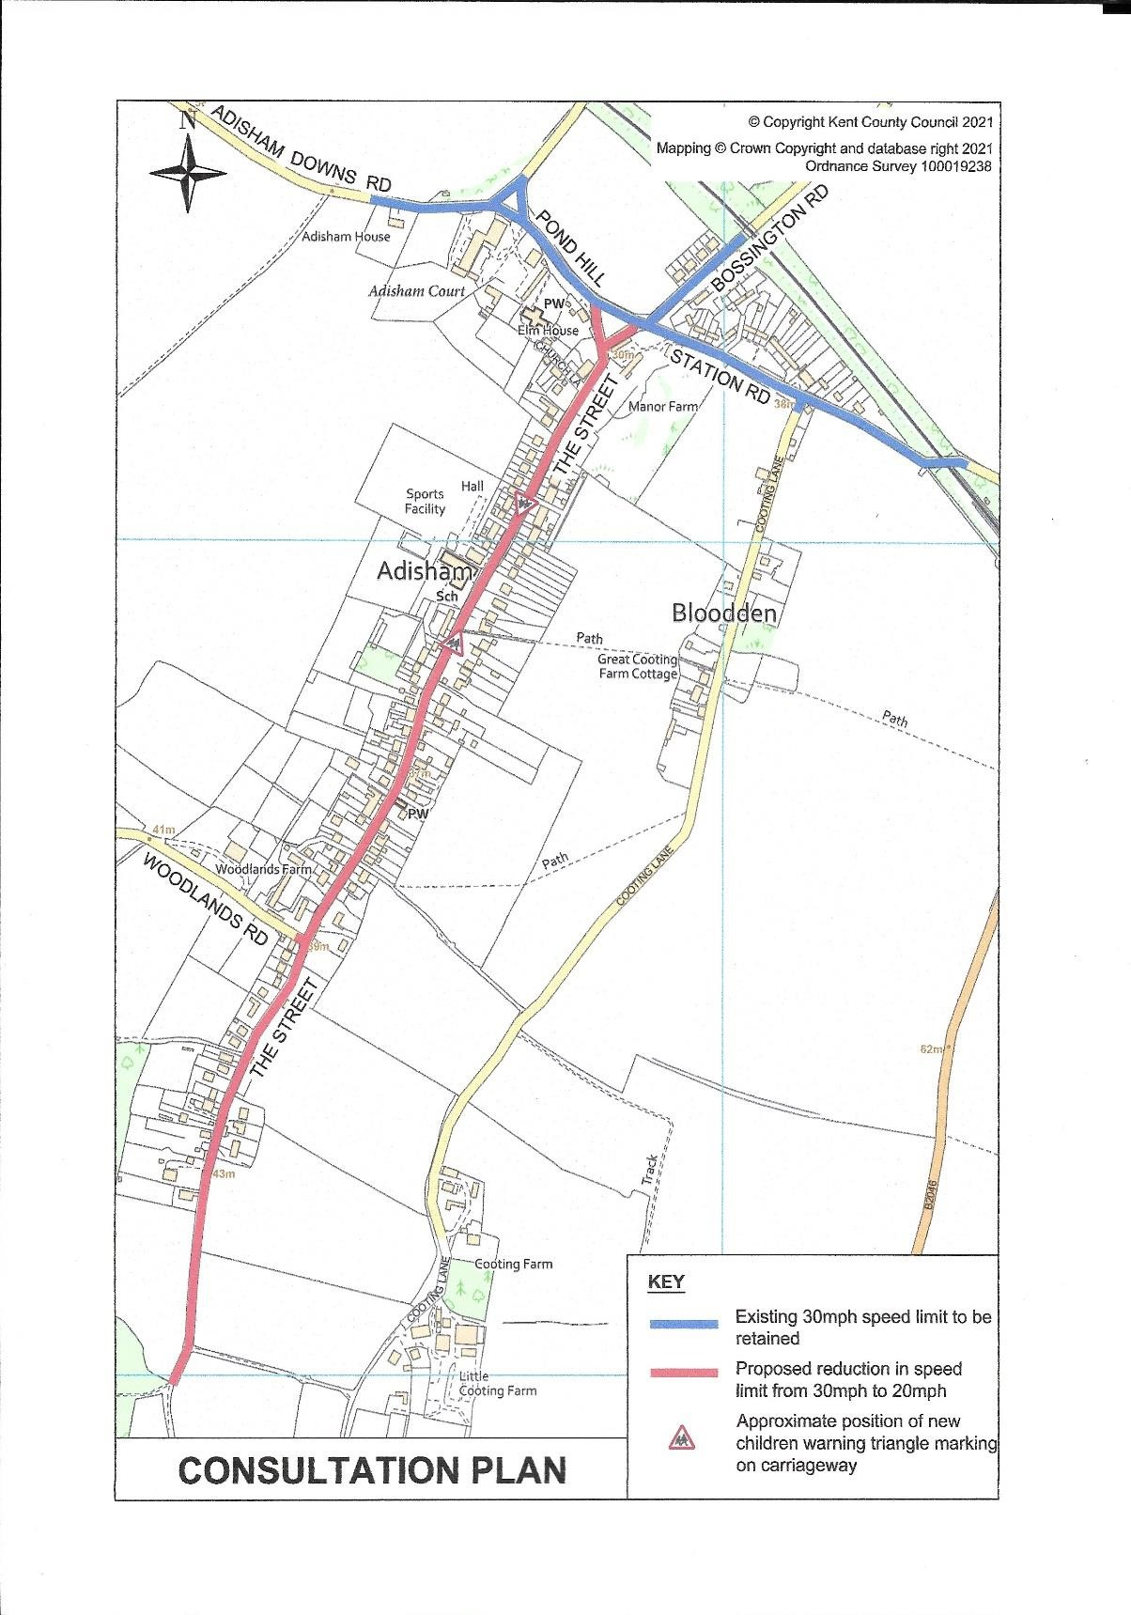

PLEASE COMPLETE THIS PAGE AND RETURN TO THE PARISH CLERK BY 31st OCTOBER 2025
Please only complete one form per household, and provide your address below.
Address:

e-mail:

WHAT IS YOUR VIEW OF A 20mph LIMIT IN ADISHAM – a positive step or a waste of money? Please give the reasons for your answer
OTHER THAN THOSE AT THE START OF THE LIMIT, WOULD YOU LIKE TO SEE ADDITIONAL SIGNS/MARKINGS TO REMIND PEOPLE OF THE LOWER SPEED? This could result in additional project costs
DO YOU HAVE ANY OTHER COMMENTS?

Continued overleaf

